What is programming ?

* Programming means giving instruction to computer, to solve a problem.
* We give instruction in high level language (like English) but compiler/interpreter will convert it into Binary.
* Because Computer understand only binary language. (0 , 1)

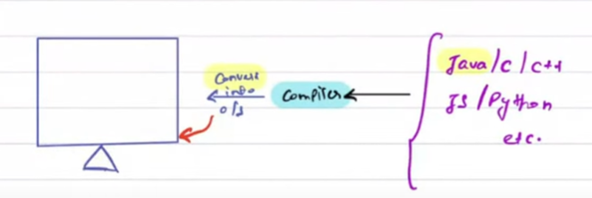

**Output Rules**

Rule No- 1 : Terminate your line with semicolon

       System.out.println(7) ;

Rule No- 2 : Java is case-sensitive language

       System.out.println(10) ;

Rule No- 3 : Inside the paranthesis, we can do maths

       System.out.print(7+10) ;

       System.out.println(7*10) ;

       System.out.println(10/5) ;

 Output

          1770

          2

      Rule No- 4: Use double quotes to print as it is

       System.out.println("10+17") ;

output -   10+17

      Rule No- 5: Concatenate different types with + while printing

        System.out.println(10+9+"Hello") ;

Output- 19Hello

Operator Rule

Compiler follow BODMAS only while evaluating expression.

Rank 1 : Brackets

Rank 2 : Multiply/Divide (left to right whatever will be first)

Rank 3: Add/Substraction (left to right whatever will be first)

  System.out.println(6+6/6) ;

Output : 7

System.out.println(4+3*6-7/2) ;

Output : 19

Data Types

Rule : You can’t declare same named variable twice.

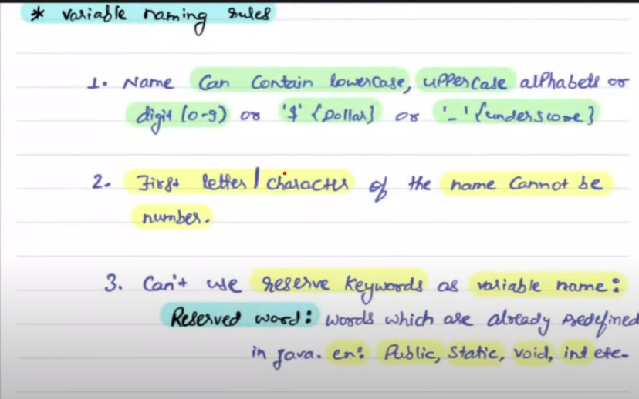

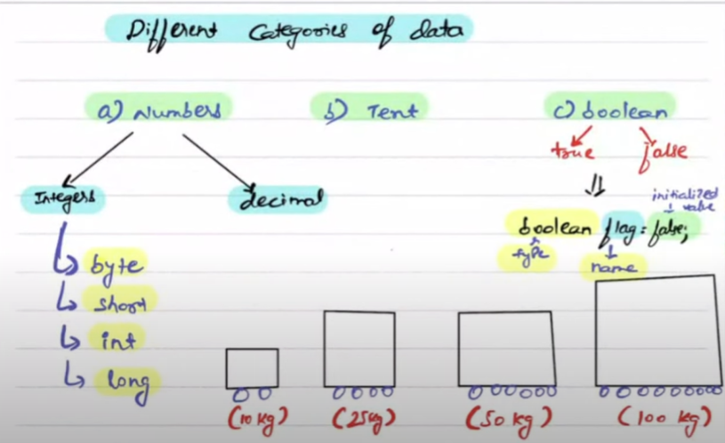

NOTE – In java if you enter any integer number it will be considered int value by default, so if any integer value is outside the range of int datatype convert it to long(by putting l at the ending of number) and store it in long variable.

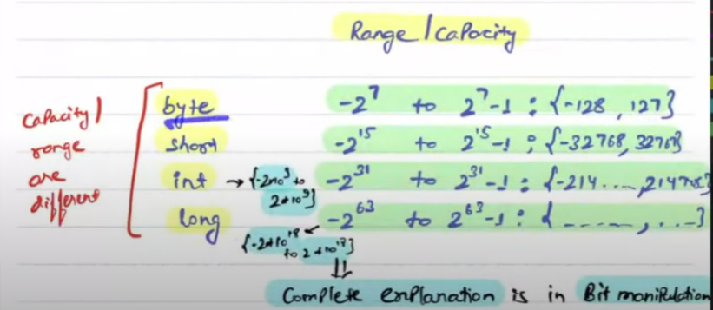

BigDecimal is used to store number which are beyond the capacity of long datatype.

BigDecimal is a class.

TYPECASTING

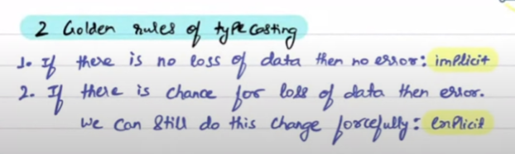

Decimal 🡪 2.2, 1.3 , 4.7 , 2.6 etc

* float and double are two datatypes to store decimals in java.
* float 🡪 4 bytes(6-7 decimal places), double 🡪 8 bytes(14-15 decimal places)
* In java, any decimal number you enter is by default double.

float b = 4.5f;

